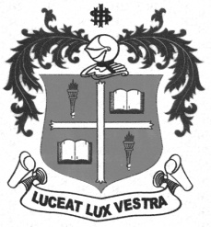
LOYOLA COLLEGE (AUTONOMOUS), CHENNAI – 600 034
B.A. DEGREE EXAMINATION – HISTORY
FIFTH SEMESTER – NOVEMBER 2012

HT 5400 - ECO. HIST. OF MODERN INDIA

Date : 10/11/2012 Dept. No. Max. : 100 Marks
Time : 9:00 - 12:00

PART – A
Answer ANY TEN questions in not exceeding Ten Lines each: (10x2=20)

- Reserve Bank of India
- Nascent Capitalism
- Shroffs and Mahajans
- Manipulation of Exchange Rates
- Trade-Capitalism
- Money Economy
- Feudalism
- Ryotwari
- National Market
- First Factory Act of 1881
- Dadabhai Naoroji
- Bengal Famine
PART – B
Answer ANY FOUR in One page each: (4x10=40)

- Trace the evolution of Modern Banking in India.
- Explain how the British fought wars at India’s cost.
- Examine how the Artisans were exploited by the Colonists.
- Write a short note on Commercialization of Agriculture.
- Give a brief note on the Food Corporation of India.
- Bring out the causes for poverty in British India.
PART – C
Answer ANY TWO questions in Four Pages each: (2x20=40)

- Discuss the features of Indian Economy in the Mid – Eighteenth Century.
- Examine the various trends towards a Market Economy.
- Evaluate the place of Entrepreneurs in the Indian Economic growth.
- Analyze the consequences of the British rule on Indian economy.
**********

